**ShopNest Store Power BI Capstone**

1. **Top categories by total prices:**

Identify and visually represent the top 10 product categories by total sales

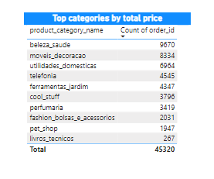

First find list of all the products and number of orders that are placed. Then sort them and find the top 10 categories out of them using filter option.

1. **Delayed Order Analysis:**

Determine the number of delayed orders in each category. An order is considered delayed if actual delivery date is later than estimated delivery date.

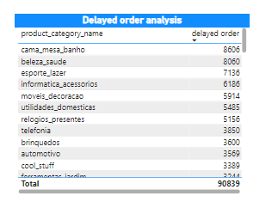

First, we need to check for if the order is delayed or not

If yes then we need to count number of delayed orders by product categories

1. **Monthly comparison of Delayed and on-time orders**

Create dynamic visual that compares number of delayed ordered to number of orders received earlier for each month.

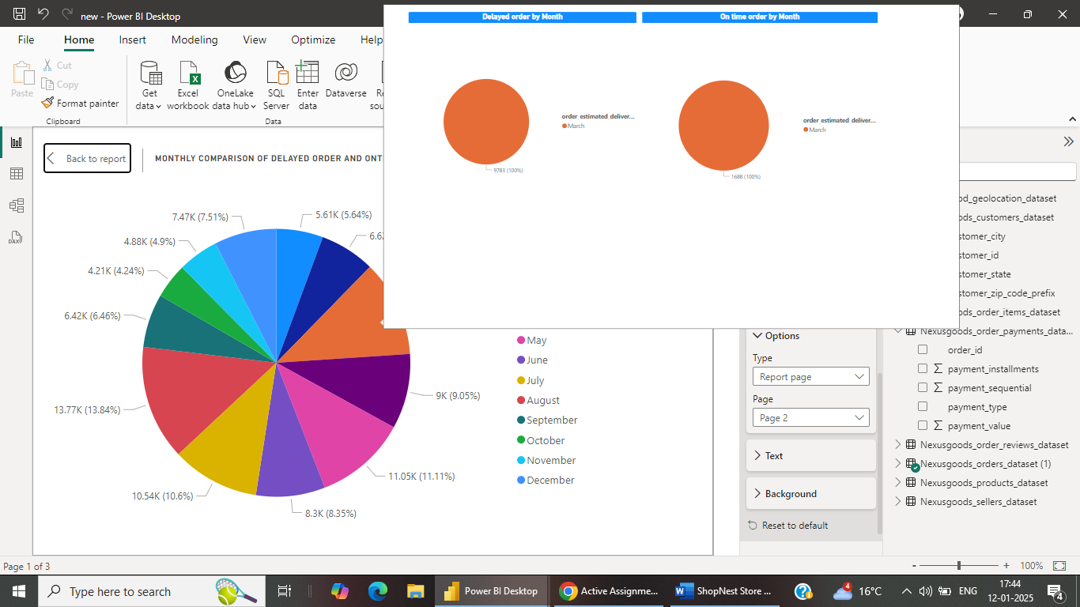

First create two measure one for delayed order and one for on-time order

Then create pie chart that handles all orders month wise

Then in each both the field that helps to see how many are on time and how many are delayed along with total number of orders in that month.

1. **Payment method analysis**

Analyze most frequent use payment methods by customers

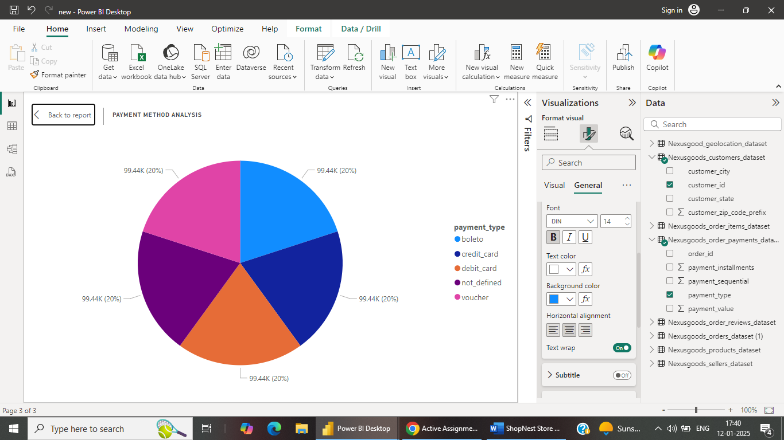

Using Pi cart add all the payment method and count of customer to that the analysis

1. **Product Rating Analysis**

Determine top 10 highest rated products and bottom 10 lowest rated products using bar chart.

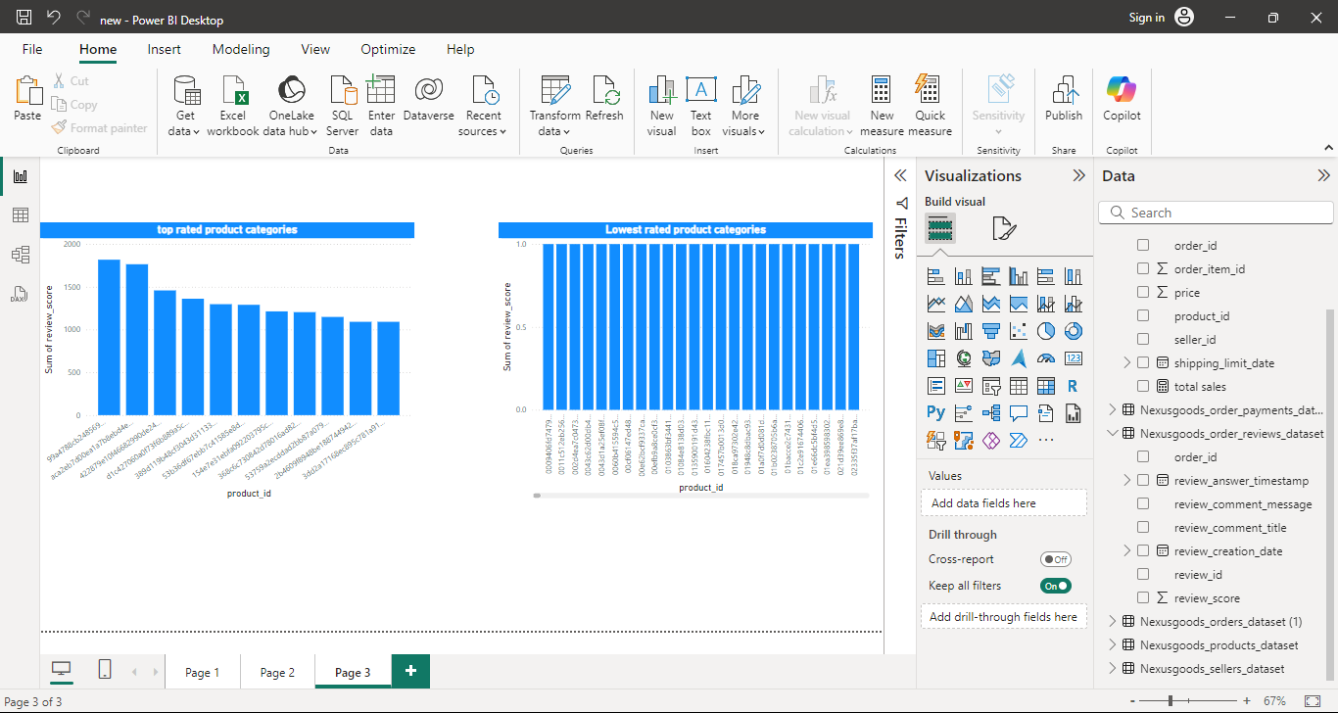

Need to list down all the product and sum the review score they have achieved.

Then find all 10 products having highest rating and similarly find 10 lowest rating products using bar chart.

1. **Sate wise sales analysis**

Investigate and visually represent states with high and low sales.

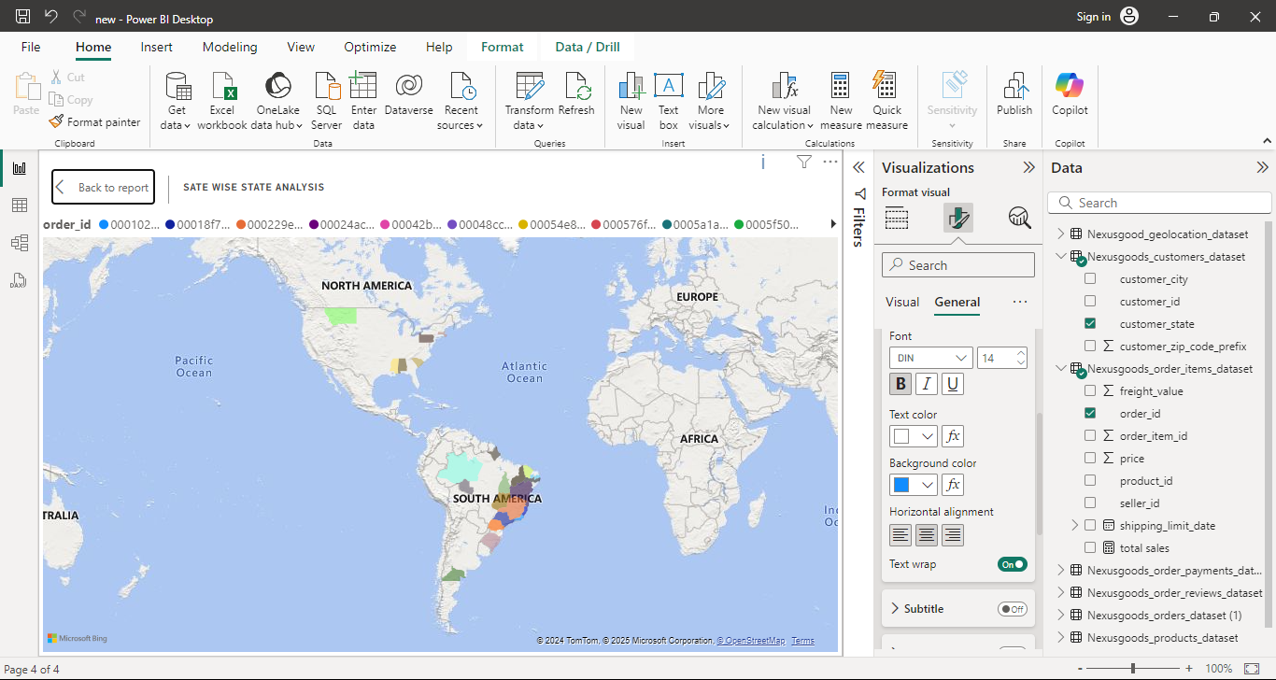

Using map, we can first show all the states present, then using legends we can mark count of sales in each state. Size of bubble indicates state performance.

1. **Seasonal sales pattern:**

Investigate and visualise any seasonal quarter in sales data over the course of the year.

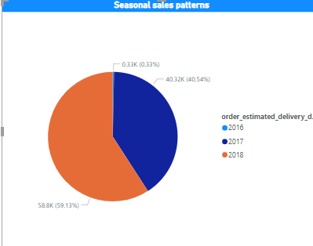

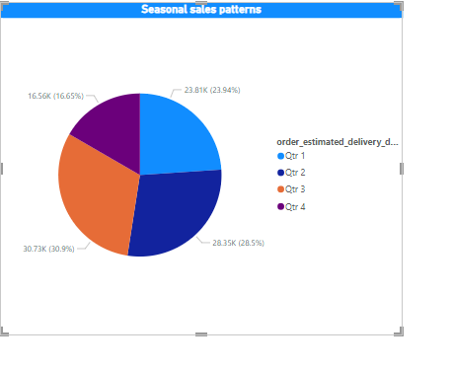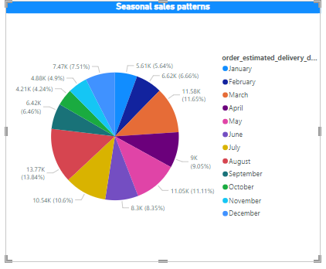

Using pie chart, we can show all seasonal data for sales

We need to select whole hierarchy of dates and using arrows on the top of the chart we can change the type in which we want to check the data.

1. **Revenue Analysis**

Determine the total revenue generated by shopnest store and anlyze how it changes over time.

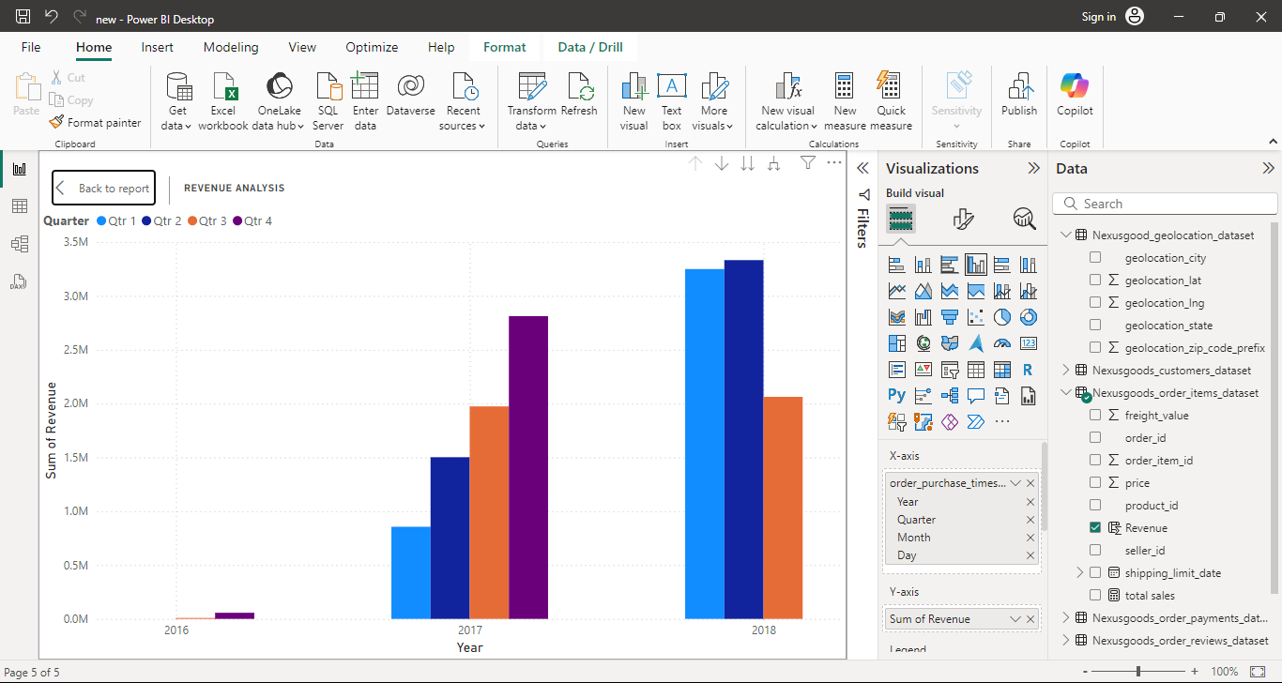

Using bar chart, we can show the whole analysis of revenue generated per quarter of each year.

Revenue = sum(order_id *(price*freight_value))